import csv

import os

#from csv import DictReader

#from typing import List, Dict

csv_path = os.path.join('budget_data.csv')

with open(csv_path, 'r') as csv_file:

    # Split the data on commas

    csv_reader = csv.reader(csv_file, delimiter=',')

    header = next(csv_reader)

    profit_loss_sum = 0

    date_count = 0

    delta_profit_counter = 0

    delta_profit = 0

    previous_profit_loss = 0

    avg_profit = 0

    delta_profit_sum =0

    greatest_inc = 0

    greatest_dec = 0

   # profit_index = None

    #table: List[Dict[str,float]]=[]

    for row in csv_reader:

        date=row[0]

        profit_loss=int(row[1])

        date_count +=1

        profit_loss_sum += profit_loss

        if date_count > 1:

            delta_profit_counter =  profit_loss - previous_profit_loss

        delta_profit_sum=delta_profit_sum+delta_profit_counter

        previous_profit_loss = int(row[1])

        if delta_profit_counter > greatest_inc:

            greatest_inc = delta_profit_counter

        if delta_profit_counter < greatest_dec:

            greatest_dec = delta_profit_counter

        #print(delta_profit_counter)

        #print(profit_loss_sum)

        #print(total_delta_profit)

total_delta_profit = delta_profit_sum/(date_count-1)

#avg_profit = sum(delta_profit_counter)/(date_count-1)

#print(profit_loss_sum)

print(f"Financial Analysis")

print(f"-------------------------------")

print(f"Total Months: {str(date_count)}")

print(f"Total: {str(profit_loss_sum)}")

print(f"Average Change: {str(total_delta_profit)}")

print(f"Greatest Increase in Profits:  {str(greatest_inc)}")

print(f"Greatest Decrease in Profits:  {str(greatest_dec)}")

#data = [row for row in csv_reader]

#date = datetime=strptime(row[0],'%m/%d')

#profit_loss=integer(row[1])

#print(f'{budget_data}')

#def print_financial_analysis(budget_csv):

 #   date = str(budget_csv[0])

  #  profit_loss = int(budget_csv[1])

PyPoll

import os

import csv

csv_path = os.path.join('PyPoll','election_data.csv')

with open(csv_path, 'r') as csv_file:

    # Split the data on commas

    csv_reader = csv.reader(csv_file, delimiter=',')

    header = next(csv_reader)

    khan_votes = 0

    correy_votes = 0

    li_votes = 0

    o_tooley_votes = 0

    for row in csv_reader:

        voter_id=int(row[0])

        candidate=str(row[2])

        if (candidate) == "O'Tooley":

            o_tooley_votes +=1

        if (candidate) == "Khan":

            khan_votes +=1

        if (candidate) == "Li":

            li_votes +=1

        if (candidate) == "Correy":

            correy_votes +=1

print(o_tooley_votes)

print(khan_votes)

print(li_votes)

print(correy_votes)

Better solution working

import os

import csv

csv_path = os.path.join('PyPoll','election_data.csv')

with open(csv_path, 'r') as csv_file:

    # Split the data on commas

    csv_reader = csv.reader(csv_file, delimiter=',')

    header = next(csv_reader)

    row_counter = 0

    candidate_list=[]

    candidate=[]

    vote_count = 0

    candidate_dict= {"Candidate":candidate, "Votes": vote_count}

    for row in csv_reader:

        row_counter+=1

        candidate= str(row[2])

        candidate_dict["Candidate"].append(candidate)

        vote_count=1

    else:

        vote_count+=1

        row_counter+=1

    print(f"Total Votes: {row_counter}")

    print(f"Vote:{print(candidate_dict)}")

        #print(voter_id)

HW hints

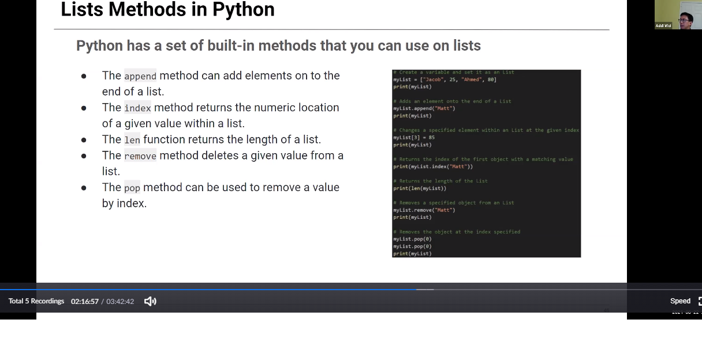

----must move analysis

